**COM621 2020 Assessment Sample**

**General comments:**

* There is a good reference section using Harvard style. It is good to have a mix of reference media. Mental research is shown. Gap in accessibility, data protection regulations and ethical issues, etc.
* Introduction provides medical background.
* Business plan shows research data for goals. Market research evidence needed to confirm that there is no similar products.
* Survey sample group stated at 17, but is the response rate 100% on each question? Good to see figures with captions to represent results. An appendix link to the raw data would be useful to support claims.
* Section 3.3.1.1 – Link to UX design principles expected. In analysis text if a direct quote is used is should be ‘*quoted italic’* with a code to identify the transcript.
* 3.3.1.3 **–** stements from the researcher like: ***‘****loan application button is eye-catching’* needs supporting evidence.
* User needs table needs a caption.
* Metrics table needs caption. Evidence needed to support your metric choices.
* Usibility test info has 5 summary tables with links to consent forms.
* Summary identifies the weakness of the project. Well done.
* Final conclusion and recommendations expected.
* Report structure could be better if the grapics were in the body text so the reader can follow better.

# Introduction

The initial COVID-19 lockdown took the world into unprecedented territory that very few were prepared for, physically and mentally. Mental health is becoming a frequent topic of conversation and rightfully so, good mental health is essential to good health. The National Institute of Mental Health (NIMH) estimated that 20.6% of the U.S population suffered from a mental illness in 2019 (Han, 2020). The number of people who suffer mental illnesses is already high, but the COVID-19 restrictions have taken its toll. A study by the Centre for Disease Control (CDC) during the after the first lockdown reports that, of the 5,470 participants, 40.9% said they experienced some form of the adverse mental or behavioural condition (Czeisler, et al., 2020), almost double the rate of before lockdown.

University students are often a forgotten demographic in these times but there are many unique challenges that students face. From dealing with social isolation while away from home, to the new teaching methods universities have implemented, students are having to adapt and how well they adapt will determine their future. A report from September 2020 states that, of the 195, students questioned, 138 (71%) say they have experienced increased stress, anxiety, and depression due to COVID-19 (Son, et al., 2020).

A contributing factor to mental health issues is a poor financial situation. From a survey of 8,454 people in debt, almost half (45%) suffer from a mental health illness, considerably more than the general population. The same study reports that people in debt have 2.5 times the rate of neurosis, thrice the rate of psychosis and more than twice the rate of alcohol dependency than people with no debt (Jenkins & Bebbington, 2008). With 71% of students worrying about making ends meet (Bishi, 2020), they are no strangers to financial struggle. In the same study, Save the Student reports that the average monthly spend for students is £223 more than the average maintenance loan which leads almost three-quarters of students (74%) to rely on part-time jobs, which in the current pandemic, are hard to find. It is important to stay keep on top of finances at university to reduce stress and achieve the best results. From the 3,161 respondents, 58% say their financial situation affects their mental health. Where students go for money can end them up in serious trouble, Save the Student reports that 2% of those surveyed use payday or commercial loans.

Payday loans are notorious for charging high-interest rates for short term loans. Although a law came into effect in 2014 that states payday loans can charge a maximum of 0.8% interest per day (Financial Conduct Authority, 2014), this could be as much as 1,500% annually compared to the typical 22.8% APR for a credit card. Payday loan companies often offer payment within an hour and a quick application process which entices users in, but most borrowers end up paying more in fees than they borrowed (Pew Charitable Trusts, 2016).

According to Save the Student, their past 5 annual finance surveys show 2% of students have used payday loans at least once during their studies. Although there is little data specifically on students use of payday loans, it can be estimated that in 12 months, undergraduate students alone pay about £5.8 million to payday loan companies (Figure 1).

Financial stress is a leading cause of many mental health issues and can negatively affect a student’s time at university. The research shows that there is a need for a new and radical system for students that gives access to financial aid with fewer risks than typical payday loans without charging the student population almost £6 million each year. This report outlines a system that will benefit students by allowing them to lend and borrow money from one another, meaning that most of the interest paid will stay within student pockets.

The proposed system, named *Kiwi*, will connect students who want to invest money with students who want to borrow money and provide a safe place to make these transactions while taking a small ‘service fee’ for the service. Building a service which can result in more student debt is unethical, to say the least, therefore the borrowers will have the opportunity to pay off their loan via work. The service will offer jobs from affiliates such as local universities, councils, employers, and job agencies which borrowers can accept to clear their loan and even earn extra money.

## Business

This service aims to provide genuine financial aid to students who need it while offering a secure platform for students to invest money. The unique selling point of this service is that financial aid can be paid off via working for various employers which will alleviate student stress by taking pressure off their financial situation so they can focus on studying. From a business standpoint, it has already been estimated that out of the 1.8 million undergraduates, those who use payday loans, spend £5,800,000 annually in interest (*Figure 1)*. *Kiwi* aims to get a 15% hold on this market over 3 years. The annual gross income would estimate £870,000 by the end of the third year. From this figure, 78% would be paid back to the student investors in interest (£678,600). 7% would build a provision fund that would protect investors on the occasion a borrower defaults on their loan (£60,900). Another 7% would cover running costs (£60,900). Leaving 8% as net profit which averages at £69,000. As can be seen, this estimation and writing, not only suggest *kiwi* be a viable business, but an ethical and profitable one.

Market research shows that there are no similar products aimed for students although peer-to-peer lending sites exist and a payday loan company which is targeted at students. The most popular peer-to-peer (P2P) lending sites, along with a student-targeted payday loan company. Existing P2P sites are not suitable for students as their minimum investment amount and duration are higher than many students will want to accept.

The service has 3 business goals:

* To provide students with a safer option for financial aid with other means of repayment in the form of work.
* To provide a low-risk service for students to invest.
* To return a profit of 8% by the end of the third trading year.

# 3. User Research Analysis

Development with user goals in mind is the most effective way of creating a service. This section will explore what students think of existing services and how they feel towards the market of short-term loans.

## 3.1 Survey Results

Mobile or web-based? A question that can be guessed but is best answered by the users. A survey, conducted by myself on 01/12/2020 via Google Forms, of 17 students revealed that when performing finance tasks (such as applying for student finance) using a PC is preferable (*figure 3)* therefore the prototype will be developed for web. The overwhelming response from students regarding short term loans is negative, with many respondents worried about getting into more debt (*figure 4, figure 5).* It is clear to see that the consensus is that payday loans do more damage than good, due to this, this prototype will promote a method for users to repay their loan through different means.

### 3.3 Contextual Interview

It is often hard to find out what is needed by simply asking questions as a lot of questions are led and users cannot always verbalise their thoughts or reason their actions, therefore observing users performing tasks can come in very handy. The following interviews follow a user as they navigate through peer-to-peer lending applications as well as short-term loan applications. This style of interview allows the interviewee to speak their mind throughout the process while allowing the interviewer to observe the user’s actions, where they click, what they read, and more importantly what they ignore. [Contextual Interview Summary](https://ssu-my.sharepoint.com/:x:/g/personal/3thomk39_solent_ac_uk/EUCAG4a_hF5NjXmzGEvhHv8BfalCyx5Brx8EW14ecZk4fQ?e=XkNSBm).

#### 3.3.1.1 Zopa – [Interview Link](https://youtu.be/QEPRsJfumAM)

The home page for Zopa was said to have limited information and the imagery and language feels irrelevant and the objective of the site is unclear without scrolling down the page although having reviews on the homepage increases trust.

Alike the homepage, the loan application was said to have a font that is too small. The interviewee said that the overall theme is bland and serious which makes the process not enjoyable. Throughout the site there appears to be too much writing, it is suggested that it could be written more concisely although the loan calculator is offered at the top of the page and at the bottom which saves scrolling back through the vast amount of text.

The invest application follows suit with the theme of the site, which is said to be boring and drab with too much white space. A handy visualisation is a 5-step process of how investments work. The user stated that the scale of the site appears to be off and that it felt ‘zoomed out’

#### 3.3.1.2 Smart-Pig – [Interview Link](https://youtu.be/td7UyEOaCTE)

Smart-Pig is aimed at students therefore the response is expected to be positive. The interviewee, regarding the home page, said the colour scheme is engaging, the loan calculator on front and centre gets users to where they need to be quick and the reviews, again, increase trust for the site. The borrow application only allows users to select £50 intervals using a slider, which is limiting but the repayment terms and cost are clear. The progress bar during the application allows users to go back to previous pages.

#### 3.3.1.3 Ratesetter – [Interview Link](https://youtu.be/TyBvsNwDWsg)

Ratesetter has a good balance of information and design, not cluttered and the tagline clearly states what the service is being offered. The loan application button is eye-catching and is one of the first elements seen although the application itself is single-page and laid out in such a way that makes the page seem cluttered even though there is ‘too much white space’. The site offers loans and investments, but the investment application cannot be found.

#### 3.3.1.4 Fund Ourselves – [Interview Link](https://youtu.be/PsE4h0z3SEc)

The loan application, like other sites, uses sliders and a calendar for the amount and duration, respectively, which is said to be an easy way to select figures. The repayment amount is visualised as initial amount, interest and total owed which means the user is wholly in the know. Unlike the other sites, the representative example is laid out nicely in a grid which increases readability and draws the user’s eye to it. All websites display a warning about getting into more debt, Fund Ourselves is the only site where the interviewee noticed it.

Throughout the 4 websites, the colour scheme played a big part in the interviewee's perception of the service. After each interview, the interviewee was asked about the information displayed in the banners and could not provide a sufficient answer. This aligns with the phenomenon which is ‘Banner Blindness’ where users consciously or unconsciously ignore banners on websites. Due to this, banners will not be used in the prototype.

To summarise, this product is exclusively for students in the UK, therefore most of the users will be aged from 18 to 25, except for mature students. Throughout the interviews, some points stood out which can be transferred to the prototype. These are as follows:

* Colour scheme must be engaging as the process of form filling can be rather boring.
* Reviews increase trust which is essential for using a new financial service.
* Accessible loan calculators throughout the site will ensure a clear service.
* Contact details throughout the loan application.
* Clickable progress bar.
* Ensure there is a warning about borrowing displayed clearly.
* A simple breakdown of the loan.
* No banners.

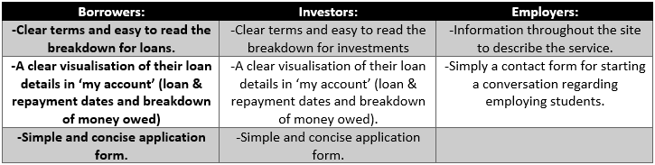The user needs are as follows:

# 4. User Journey

This product has three user types: borrower, lender and employer. The user journeys, personas and metrics used to measure usability can be found in this section.

## Borrower

[Borrower Jamie - Persona](https://ssu-my.sharepoint.com/:b:/g/personal/3thomk39_solent_ac_uk/EW02ymGq3l9DjMs7dAQ9FwwB063Gmj1NmgJ-cFMS88QsCw?e=R2pTCS)

[Borrower Jamie - User Journey](https://ssu-my.sharepoint.com/:b:/g/personal/3thomk39_solent_ac_uk/EdMn1_OsCCBFtws9XeWI2NgBt5mxw4i0-xstNOgMmghyhA?e=f3Kvyu)

## Lender

[Lender Thomas - Persona](https://ssu-my.sharepoint.com/:b:/g/personal/3thomk39_solent_ac_uk/EQABTUIzb2pHrur2HrTYRWMBSxB-5kjaW_I4aAixPPZAZw?e=XjjTQa)

[Lender Thomas - User Journey](https://ssu-my.sharepoint.com/:b:/g/personal/3thomk39_solent_ac_uk/EfaKHdngQqJBheYNsHshC1ABHHxBDztunMtkOaMgpbOryQ?e=uJtnrC)

## Employer

[Employer Nicola - Persona](https://ssu-my.sharepoint.com/:b:/g/personal/3thomk39_solent_ac_uk/Ed0_9YkTAOtLtH6_wT7aczQBJmV0pgexiYjaG30_xeyRTQ?e=Ni1gkO)

[Employer Nicola - User Journey](https://ssu-my.sharepoint.com/:b:/g/personal/3thomk39_solent_ac_uk/EZM-F4SagthPhI-on97n_jYB81Ghu5NdYyi1AZY2COtpyQ?e=Kgm58K)

## User Usability

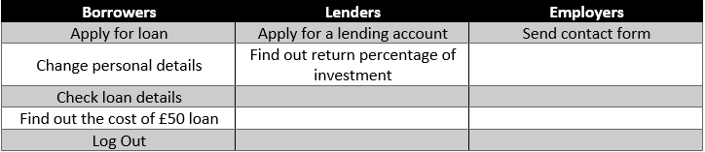Users will be asked to perform the following tasks to test the usability.

The metrics measured will be:

# 5. Prototype

The prototype has been developed on Adobe XD and can be accessed with the following link:   
[Adobe XD Prototype](https://xd.adobe.com/view/afdfb7f9-787c-454c-9392-7931fd21ead5-fa8c/?fullscreen)  
An example run through video for the prototype is found here:  
[Prototype Run Through](https://youtu.be/AuXrtYqL9vQ)

6. Usability Testing

A deductive test has been designed as there are no known problems in the prototype that are being targeted. 5 users will be asked to perform the following tasks:

1. Find out how much a £50 loan would cost for 15 days.   
2. Apply for a loan.  
3. Check loan details.  
4. Change personal details.  
6. Log out.  
5. Find out the projected return percentage for an investment of £150 for 3 months.  
7. Apply for Investor Account.  
8. Enquire about employing through Kiwi.

This test is preliminarily designed to target navigation but wil also test the language and information architecture of the site. The user is asked to rank each task form 1 (easy) to 5 (hard) in terms of difficulty using Google Forms. The footage is then analysed, and the number of errors collated along with the duration of each task.

## 6.1 Usability Test 1

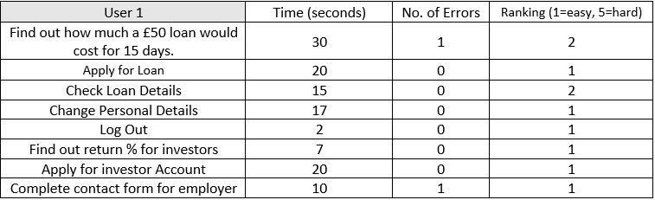The video for user 1 can be found here along with their consent form:  
[Usability Test 1](https://youtu.be/4D_ZTy3OjtQ)  
[Consent Form 1](https://ssu-my.sharepoint.com/:b:/g/personal/3thomk39_solent_ac_uk/EYLBefp1wxlNmKOk9EfKZTMBXvJQM9sSzyfwLTBH33YiEg?e=Ne76Js)

User 1 experienced 2 errors; firstly, the initial page of the loan application does not display the cost until the duration is selected, this could be changed so it uses the data which is input into the previous page. Secondly, when checking loan details in the ‘My Account’ section the visualising of the loan was said to be initially confusing but then became clear. Also, it was noted when contacting *Kiwi,* as an employer, some text on the employer page is slightly hard to read.

## 6.2 Usability Test 2

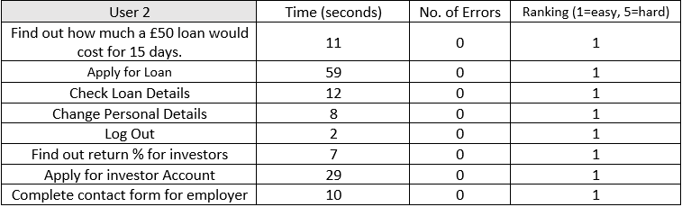The video and consent form can be found here:  
[Usability Test 2](https://youtu.be/swoKTLvQ0d8)  
[Consent Form 2](https://ssu-my.sharepoint.com/:b:/g/personal/3thomk39_solent_ac_uk/ERYpvdUGjN1NtOP_tzmmGoMBDD2Qo03hfnGnrfaudLoW_w?e=MVYlHs)

User 2 faced no problems while traversing through the various tasks.

## 6.3 Usability Test 3

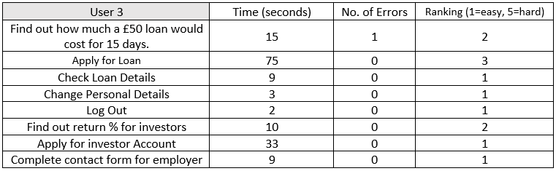The video and consent form can be found here:  
[Usability Test 3](https://youtu.be/OFXImAMUOSI)  
[Consent Form 3](https://docs.google.com/document/d/1k0-L_q2br_XezZZR905ZrxIawf51gOWU3a9gk9QYAi8/edit?usp=sharing)

During task 1, the user mistook ‘when do you get your next student loan’ with ‘When do you want to repay your loan'. The ‘loan details’ section on the application form was said to be ‘busy’.

## 6.4 Usability Test 4

The video and consent form can be found here: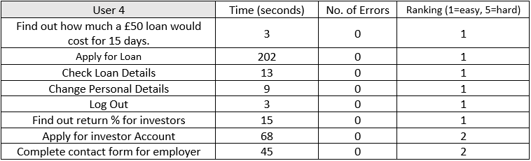  
[Usability Test 4](https://youtu.be/3-Ox8mt2Xjo)  
[Consent Form 4](https://docs.google.com/document/d/1GV5WBoZEomnDlX_RZr62nLdaL-bjPx_JL5dt51eq1Gw/edit?usp=sharing)

‘What’s the loan for’ question suggested to be a dropdown instead of a text field which would make the inputs easier to manage as there are only a few options that most users would choose. The user noted that the site is friendly. During application process it was noted that the ‘create account’ button appeared too early on which could lead to minor confusion. The font has been commented on, more specifically the colour of the font against the background is sometimes hard to read and the choice of title font that is seen throughout as headers can sometimes be hard to read, especially when the user is not wearing their glasses. The homepage features a font that does not fit with the theme.

## 6.5 Usability Test 5

|  |  |  |  |
| --- | --- | --- | --- |
| User 5 | Time (seconds) | No. of Errors | Ranking (1=easy, 5=hard) |
| Find out how much a £50 loan would cost for 15 days. | 30 | 0 | 2 |
| Apply for Loan | 90 | 0 | 1 |
| Check Loan Details | 10 | 0 | 1 |
| Change Personal Details | 6 | 0 | 1 |
| Log Out | 2 | 0 | 1 |
| Find out return % for investors | 8 | 0 | 1 |
| Apply for investor Account | 37 | 0 | 2 |
| Complete contact form for employer | 28 | 0 | 2 |

The video and consent form can be found here:  
[Usability Test 5](https://youtu.be/3i_RxiCzjMM)  
[Consent Form 5](https://docs.google.com/document/d/1QO5oRFF99RU0XI94bD6YxPB0WjnMxWfaIcU4zUOxvDs/edit?usp=sharing)

The loan details are clearly displayed. Suggestion for homepage to display the entire ‘borrow’ ‘invest’ and ‘employ’ information boxes above the fold, but the suggestion has been ignored as it would be too cluttered.

## 6.5 Usability Summary

In hindsight, the usability test should have asked users to ‘request work’ and ‘request a payment plan’, options which are only available through the ‘My Account’ page. After a discussion with user 4 regarding this matter the conclusion was, although these options are there for users who are struggling to pay back their loan, they should not be overly accessible as most borrowers would ideally pay back their loan back the traditional way.

The Google Form questionnaire has been visualised below. The graph shows task 4, 5 and 6 had no problems. 1 user was challenged by task 2, due to misreading one of the form fields and feeling the first page of the form field was ‘cluttered’ but the rest of the users experienced no problems on task 1. The most common problem occurred in the first task, with 3 out of 5 users ranking the difficulty a 2, this shows that the loan calculator could be remodelled for a clearer understanding. 2 users faced challenges when performing task 7 and task 8, firstly due to some of the font not being clear to read and secondly on the ‘Employer’ page the contact form isn’t at immediately available.

## Satisfaction Survey

Based on the usability tests there some changes that could be made to increase usability:

* First page of loan application should display information input to the loan calculator
* The loan calculator could put more emphasis on ‘when do you get your next student loan’ to differentiate it from ‘when do you want to repay your loan’.
* Text on the employer page can be made darker to increase readability.
* The loan details within ‘My Account’ are displayed on a timeline which 1 user found to be initially confusing so the visualisation of this information could be changed to help users understand.
* ‘What’s the loan for’ text field to be changed to a dropdown selection.
* ‘Create Account’ button appears too early in the application process.
* Employer contact form to be moved, or duplicated, at the top of the screen.

# 7. Figures

Figure Estimate of how much interest is paid by students to payday companies.

|  |  |  |  |  |  |  |  |
| --- | --- | --- | --- | --- | --- | --- | --- |
| Facts | Percentage of students that use payday loans. | Number of students in the UK  (million) | Estimated number of Students using Payday loans | Average loan amount | Average repayment factor: | Average Interest: | Total Estimated Interest Paid by Students to Payday Loan Companies Annually. |
| Figures | 2% | 2.38 Students  1.8 Undergrad | 36,000 | £250 | 1.65 | £162.50 | £5,850,000.00 |
| Source | (Bishi, 2020), (Bushi, 2019),  (Bishi, 2018),  (Butler, 2017),  (Butler, 2016) | (Universities UK, 2020) | Calculation | (Financial Conduct Authority, 2019) | (Financial Conduct Authority, 2019) | Calculation | Calculation |
| Notes: | As the data is not available, it is assumed that each of the 2% only used payday loans only once. | | | | | | |
|  | To make a more reasonable estimate, results will be based on undergraduates only as postgraduates are assumed to have better money management skills due to have being a student for 3-4 years | | | | | | |

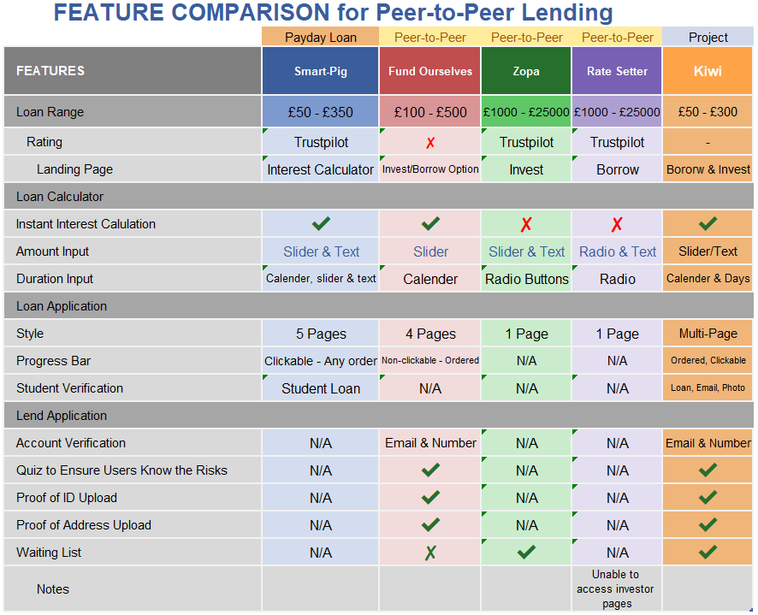

Figure 2 Feature Comparison Matrix

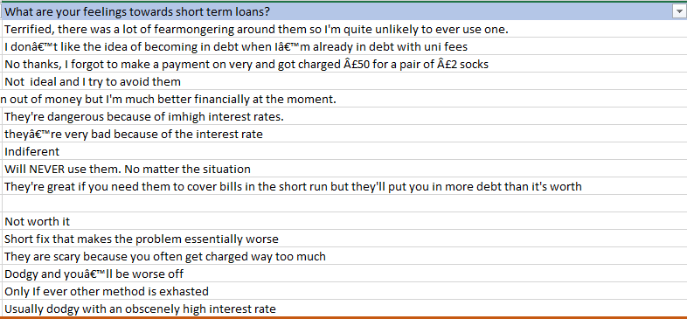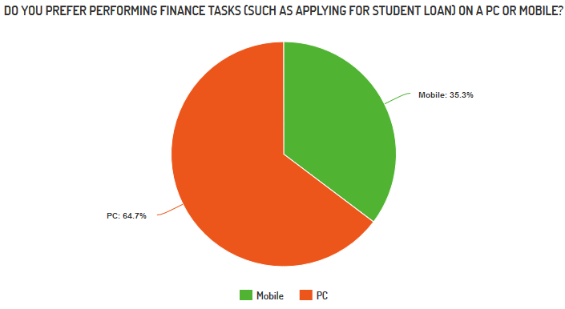

Figure Feelings towards short term loans

Figure Mobile or PC?

# 8. References

Czeisler, M. É. et al., 2020. *Mental Health, Substance Abuse, and Suicidal Ideation During the COVID-19 Pandemic,* s.l.: Centers for Disease Control and Prevention.

Financial Conduct Authority, 2014. *CA confirms price cap rules for payday lenders.* [Online]   
Available at: https://www.fca.org.uk/news/press-releases/fca-confirms-price-cap-rules-payday-lenders  
[Accessed 24 11 2020].

Financial Conduct Authority, 2019. *Consumer credit — high-cost short-term credit lending data.* [Online]   
Available at: https://www.fca.org.uk/data/consumer-credit-high-cost-short-term-credit-lending-data-jan-2019  
[Accessed 24 11 2020].

Han, B., 2020. *Key Substance Use and Mental Health Indicators: Results from the 2019 National Survey on Drug Use and Health,* Rockville, MD: Substance Abuse and Mental Health Services Administration.

Jenkins, R. & Bebbington, P. E., 2008. *Mental Disorder in People with Debt in the General Population,* London: ResearchGate.

Pew Charitable Trusts, 2016. *Payday Loan Facts and the CFPB's Impact.* [Online]   
Available at: https://www.pewtrusts.org/-/media/assets/2016/06/payday_loan_facts_and_the_cfpbs_impact.pdf  
[Accessed 24 11 2020].

Polito, S., Holmes, K., King, R. & Tutton, T., 2015. *Payday Lending Market Investigation,* s.l.: Competition & Markets Authority.

Save the Student, 2020. *Student Money Survey 2020 - Results.* [Online]   
Available at: https://www.savethestudent.org/money/student-money-survey-2020.html#earn  
[Accessed 24 11 2020].

Son, C. et al., 2020. *Effects of COVID-19 on College Students’ Mental Health in the United States: Interview Survey Study,* [: JMIR Prublications.

Universities UK, 2020. *Higher education in numbers.* [Online]   
Available at: https://www.universitiesuk.ac.uk/facts-and-stats/Pages/higher-education-data.aspx  
[Accessed 24 11 2020].